BASH SCRIPTING – 01

• As a part of automation we will be use of bash Scripting in the linux environment

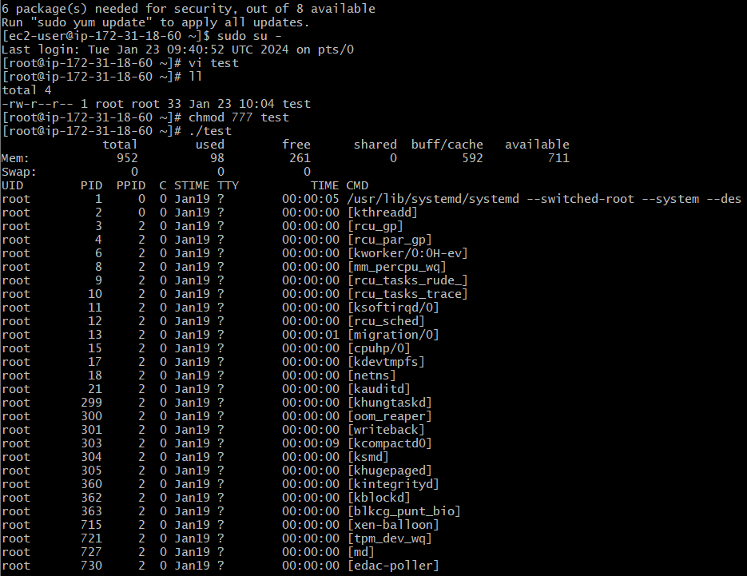

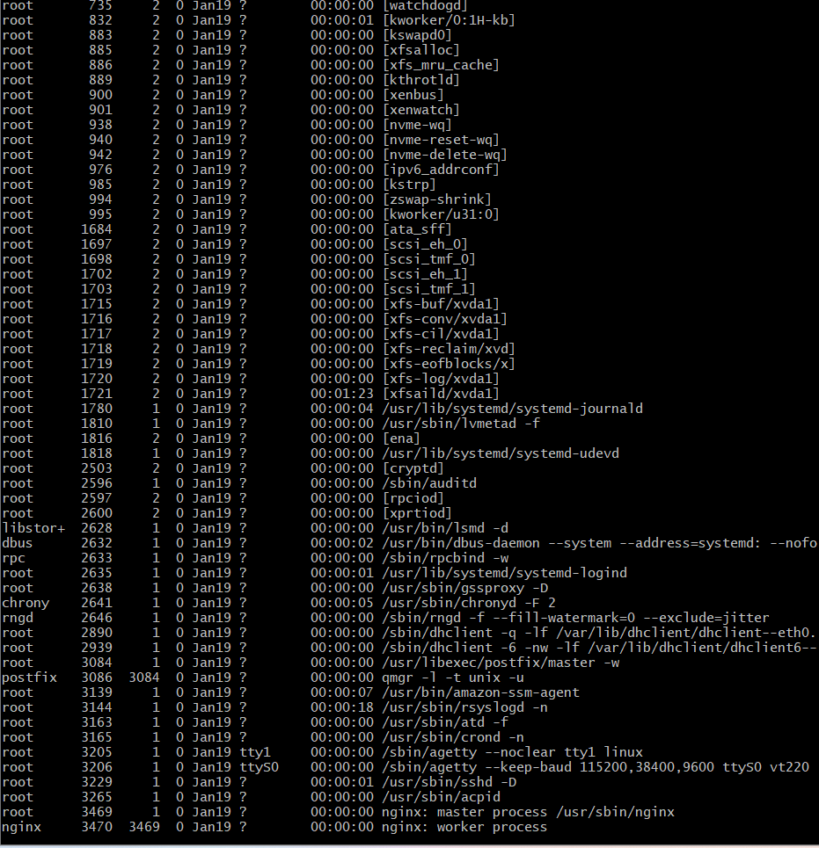



• Cat /etc/shells: will display all the available shells They are of 6 types :- 1.Gnome 2.Kde 3.sh 4.Bash shell 5.Csh and tcsh 6.korn shell

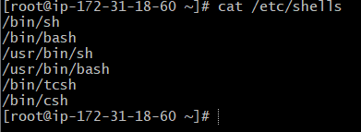

Make a directory Anusha /scripts and change directory

* Create a file and add content using echo and execute script by ./scriptname and gives output which echo commands.
* And we also check script in root by /Anusha/script/script name
* All scripts to be executed should have proper executable file permissions with the help of chmod command

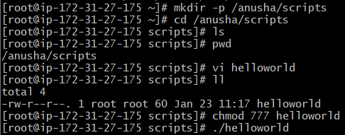

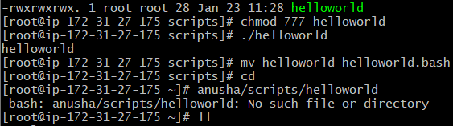

To switch b/w different sheels command:- shell name and enter ex:sh

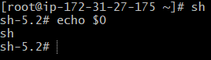

To exit from shell we can use:exit command

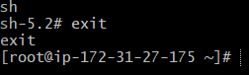

We can Execute a script in two ways :-

./file name or bash file name



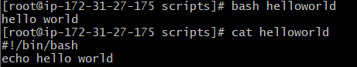

These comments help us to understand the script.

example

#!/bin/bash

# Purpose: Testing script format

#Date: 23-01-2024

#Modification: 23-01-2024

a=Hello monu

echo ‘Hello monu’

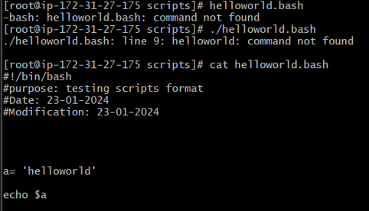

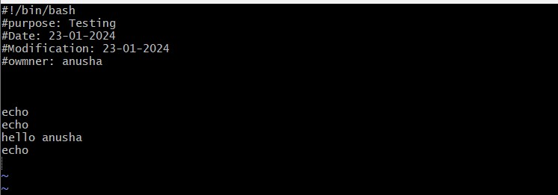

Creating a New script with

Pwd

Ls

Whoami

Date

Cal

Touch a b c

To execute that first we have to give permission chmod 775

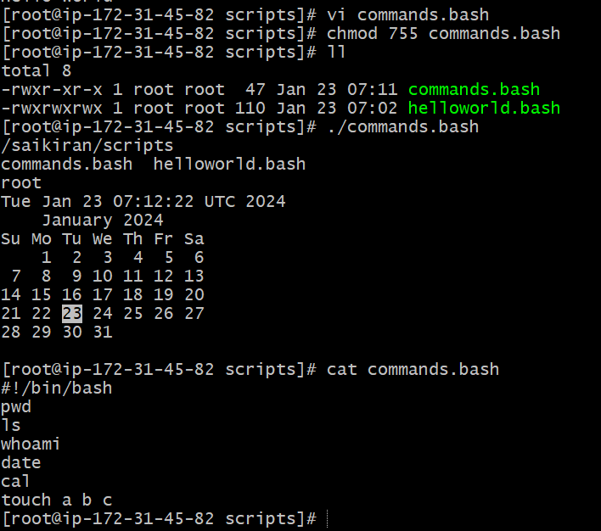

Adminstration task :-

1.top 2.df-h 3.free -m

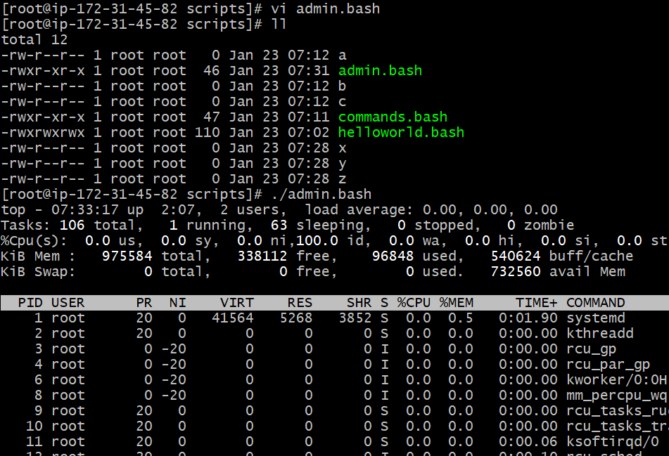

Variables task - define variables through script

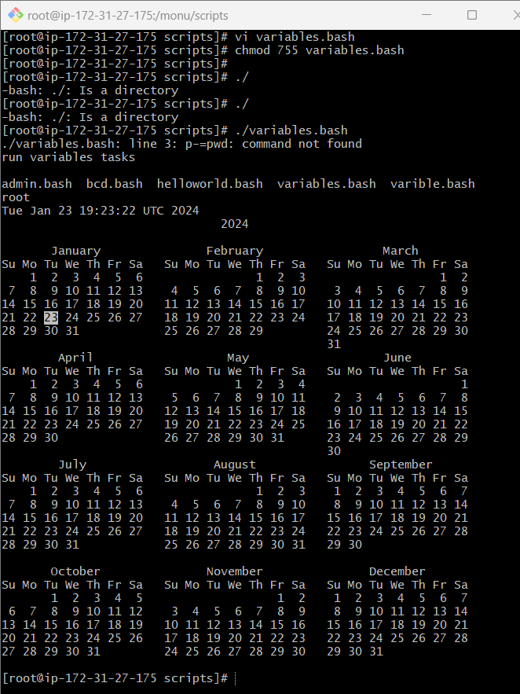

Input and ouput commands

Input commands

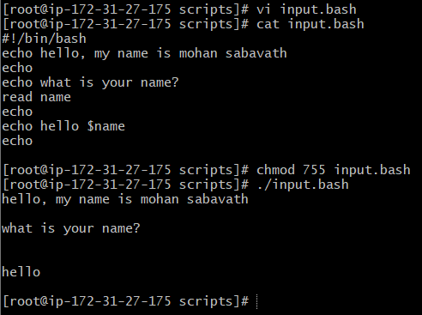

Out put commands

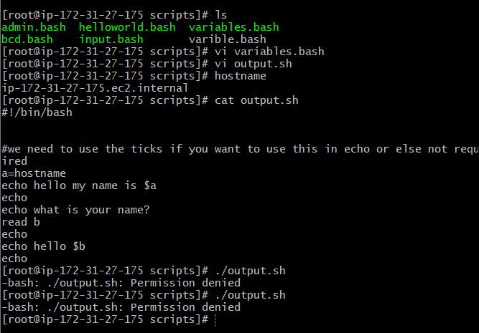b